**MAD PROJECT REPORT**

**Space Slimes**

**GROUP MEMBERS:**

**Faraz Ghani (21SW081)**

**Muhammad Daniyal (21SW03)**

**Muhammad Moiz (21-20SW127)**

**ASSIGNED BY: Mam Mariam Memon**

### Problem Statement

With the rise in mobile gaming, many users seek engaging, quick, and accessible games that they can play during short breaks or commutes. However, many existing games in this genre lack unique mechanics or replayability, leading to user boredom and decreased retention. Our target audience, mainly casual gamers, needs a fresh, engaging experience that balances simplicity with elements that encourage prolonged play and repeated engagement.

### Solution

Our project, an endless runner mobile game built on Unity, addresses this need by offering a dynamic, immersive experience with unique gameplay mechanics and a progression system. The game combines intuitive controls with procedurally generated obstacles, increasing difficulty levels, and customizable character elements to keep users engaged. By designing the game with minimal loading times and a captivating art style, we aim to create a game that appeals to both novice and experienced players, providing a quick yet satisfying gaming experience that encourages repeated play.

## ****Key Features of the Game****

### ****Increasing Difficulty Curve**:** As the player progresses, the game gradually increases in speed and introduces new obstacles, creating a continuously challenging experience.

### ****Simple, Intuitive Controls**:** Designed for mobile & Windows, the controls are easy to pick up, making it accessible for new players while still providing depth for skilled players.3.

### ****Immersive Sound and Graphics**:** The game includes retro visuals and an engaging soundtrack to provide an immersive gaming experience.

Some Glimpses Of Our Game

Development:

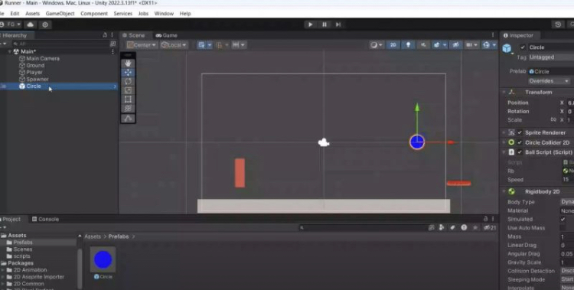

Main Menu

Gameplay

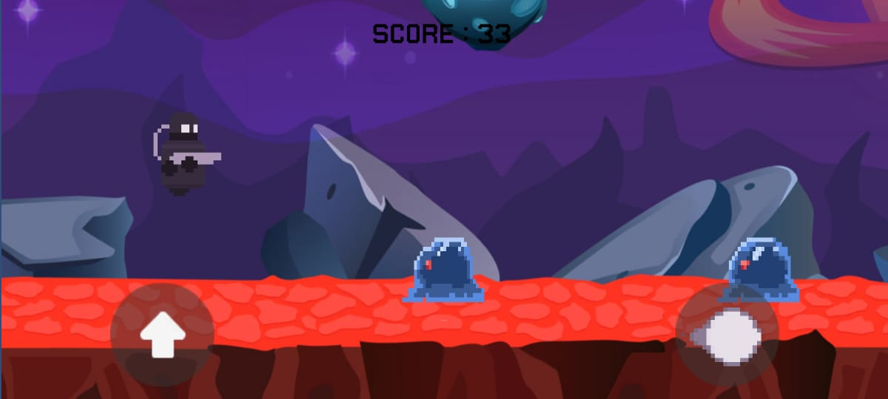

Game Over Screen

